Unit 6.6 Guided Capstone Project Report

Jeffrey Jex

# Background

Big Mountain resort is currently the most well-equipped ski parks in its market segment in Montana. It has the longest run, the most skiable terrain, the most night skiing and has been operating for 72 years. For these reasons, it currently has the highest price in Montana, $81 for both adult and weekend tickets.

Big Mountain recently put in another chair lift, increasing its operating costs by $1,540,000 this season. There is not clear line of sight on how this amenity, nor the existing facilities should affect ticket price, and ultimately revenue. Big Mountain is already the most expensive in the state, which sounds fair, but how does this compare with out-of-state competition? Is Big Mountain being short changed by only looking small competition?

Competitor comparison

Big Mountain has the most expensive tickets in Montana, but in the market segment, it lands at the 81st percentile, indicating 20% of parks are more expensive, so it wouldn’t be unprecedented to raise the price if it’s warranted.

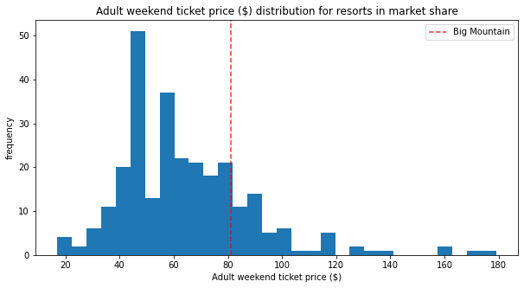

Figure : Weekend ticket price histogram for market share. Big Mountain is in the 81st percentile, but not an outlier.

There’s no single good metric for price (hence the current situation), though several key features have a strong influence in either the random forest or linear regression model.

* Vertical drop
* Snow Making_ac
* total_chairs
* fastQuads
* Runs
* LongestRun_mi
* trams
* SkiableTerrain_ac

Changes to these will affect the ticket price more than changes in other area.

# Modeling decisions

This model only uses the adult weekend ticket price to simplify things and because more weekend prices were available than weekdays. They have a strong correlation, and this seems like a valid call seeing that all parks in Montana in particular have the same weekend and weekday price. Changes to the weekday vs. weekend price is a great topic for further study.

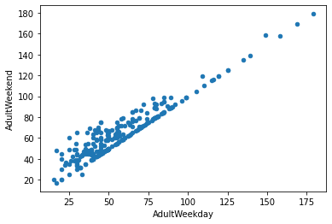

Figure , Adult weekday vs. Adult Weekend prices. Strong correlation. The weekend price is never lower than the weekday price, but is sometimes higher.

# Recommendations

I'd recommend raising the ticket price $4 on the conservative side based off the modeling.

Other changes to consider are scenario 1 and 2:

1. Drop up to 5 runs if the operational savings to do so are greater than the ~$1,200,000 of revenue lost by lowering the ticket price to account for it.
2. Increase the vertical drop and add an additional chair with no extra snow coverage. This easily covers the operating expense of the additional chair with a $1.99 raise to ticket prices.

**Details on recommendations:**

Big Mountain Resort's modelled price is $95.87, which is $14.87 higher than the actual price (18%) Even with the expected mean absolute error of $10.39, this suggests there is room for an increase.

This study considered 4 scenarios, the changes to ticket prices are below:

1. Permanently closing down up to 10 of the least used runs.
   * The model says closing one run makes no difference. Closing 2 and 3 successively reduces support for ticket price and so revenue. If Big Mountain closes down 3 runs, it seems they may as well close down 4 or 5 as there's no further loss in ticket price. Increasing the closures down to 6 or more leads to a large drop.
   * This is assuming 350,000 visitors a year, on average buying 5 tickets each.

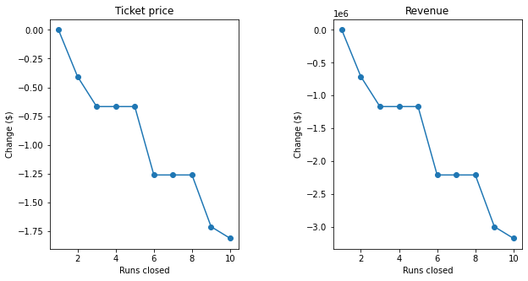

Figure effect of dropping runs from big mountain resort on both Ticket price (left) and Revenue (right)

1. Increase the vertical drop by adding a run to a point 150 feet lower down but requiring the installation of an additional chair lift to bring skiers back up, without additional snow making coverage
   * This scenario increases support for ticket price by $1.99
   * Over the season, this could be expected to amount to $3,474,638
   * An additional chair lift adds $1,540,000 of operating cost, which can easily be handled by the increased revenue.
2. Same as number 2, but adding 2 acres of snow making cover
   * The extra 2 acres of snow cover makes no difference to the ticket price.
3. Increase the longest run by 0.2 mile to boast 3.5 miles length, requiring an additional snow making coverage of 4 acres
   * A slightly longer run and just 4 extra acres of snow cover also make no difference to the ticket price